

IS630 STATISTICAL THINKING FOR DATA SCIENCE

PROJECT TITLE: IS SINGAPORE HEALTHCARE ADEQUATE FOR THE AGING POPULATION

IS630-G1-TEAM3:
CHENG HO WANG
HONG HUAJIE
TEO CHER IN
WU JIAYAN
YE ZHILI
YEE WEICONG MARK

Contents
1. Introduction 3
2. Problem, Motivation and Objectives 3
2.1Problem 3
2.2 Analytical Questions 3
2.3 Context and Novelty 3
3. Data Sources 4
3.1 Dataset and Variables 4
3.2 Data Quality and Preparation 4
4. Methodology and Results 4
4.1 Approach / Methodology 4
4.2 Results 4
4.3Discussion / Insights 4
5. Conclusion 4

Introduction

Problem, Motivation and Objectives

2.1Problem

2.2 Analytical Questions

2.3 Context and Novelty

Data Sources

3.1 Dataset and Variables

3.2 Data Quality and Preparation

Methodology and Results

4.1 Approach / Methodology
Descriptive Statistics

Inferential Statistics

Correlation Analysis
Objective
The objective of the correlation analysis was to assess whether Singapore’s healthcare capacity and expenditure have kept pace with its ageing population by examining the strength and direction of relationships between key demographic, healthcare, and economic indicators.
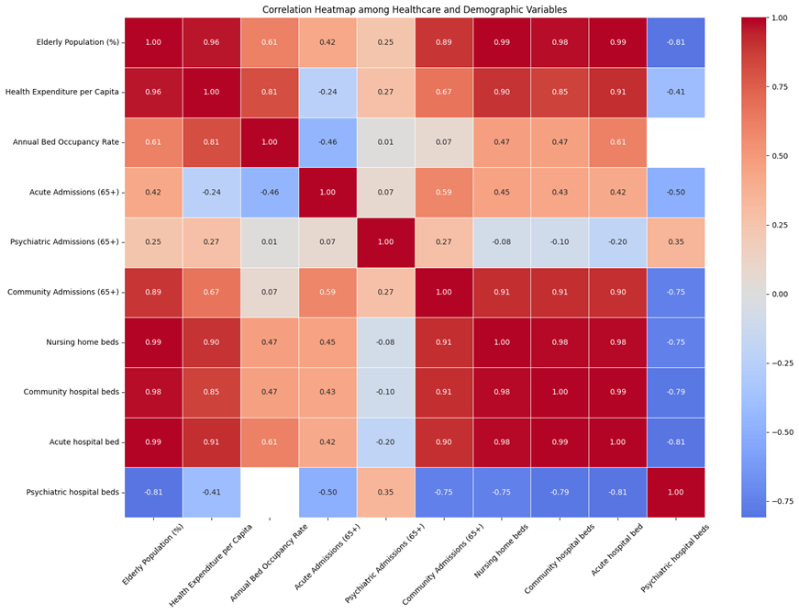

Key Correlation Findings
Relationship | Correlation (r) | Insight
Elderly Population (%) ↔ Health Expenditure per Capita | 0.96 | Ageing directly drives higher per-person healthcare costs due to chronic and long-term care needs.
Elderly Population (%) ↔ Hospital Beds | 0.98–0.99 | Hospital infrastructure expansion strongly tracks ageing trends — reflects responsive policy planning.
Health Expenditure ↔ Bed Occupancy Rate | 0.81 | Rising spending aligns with higher utilization, suggesting resources are fully absorbed by demand.
Elderly Population (%) ↔ Community Hospital Admission Rate | 0.89 | Community hospital admissions rate rises significantly with elderly %, signals that post-acute or rehabilitation demand is rising in step with ageing.
Elderly Population (%) ↔ Psychiatric Beds | –0.81 | Mental health capacity has not expanded at the same pace as physical healthcare infrastructure.

Interpretation:
Overall, the results indicate that Singapore’s healthcare infrastructure has evolved in tandem with population ageing.
- The strong correlations (r > 0.9) between elderly proportion, health expenditure, and hospital beds suggest that healthcare resources have expanded proportionally with demographic trends.
- The positive correlation between expenditure and bed occupancy rate (r = 0.81) implies that new investments are rapidly absorbed by demand, indicating a system operating near capacity limits.
- However, the negative correlation (r = –0.81) between elderly proportion and psychiatric hospital beds highlights that mental health care infrastructure has lagged behind other healthcare segments. This suggests that while Singapore’s overall healthcare capacity is responsive, specific areas such as geriatric mental health remain underdeveloped.

Hypothesis Testing

Correlation Significance Test
Purpose: To verify the significance of observed relationships, Pearson correlation significance tests were conducted for the elderly population percentage against various healthcare variables.

Test Results
Relationship | Correlation (r) | p-value | Conclusion
Elderly % ↔ Health Expenditure per Capita | 0.959 | 1.17 × 10⁻⁵ | Significant (p < 0.05). Reject H₀. Strong positive relationship.
Elderly % ↔ Acute Hospital Beds | 0.992 | 1.19 × 10⁻¹⁵ | Significant (p < 0.05). Reject H₀. Strong positive relationship.
Elderly % ↔ Community Hospital Beds | 0.976 | 4.86 × 10⁻¹² | Significant (p < 0.05). Reject H₀. Strong positive relationship.
Elderly % ↔ Nursing Home Beds | 0.988 | 2.75 × 10⁻¹⁴ | Significant (p < 0.05). Reject H₀. Strong positive relationship.

Interpretation
All p-values are below 0.05, confirming that the correlations are statistically significant and unlikely to have occurred by chance. Therefore, increases in the elderly population are significantly associated with increases in healthcare infrastructure and expenditure.

Regression Coefficient Significance
Purpose: To further quantify the impact of ageing on healthcare spending, a simple linear regression was conducted with health expenditure per capita as the dependent variable and elderly proportion (%) as the independent variable.

Test Results
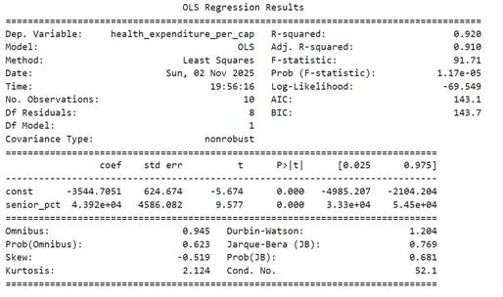
Statistic | Result | Interpretation
R² | 0.92 | 92% of variation in healthcare expenditure is explained by changes in the elderly population share.
p-value | < 0.01 | The relationship is statistically significant.
β₁ (Elderly %) | Positive | Health expenditure per capita increases as the proportion of elderly residents rises.

Interpretation:
The regression confirms that demographic ageing is a strong and statistically significant predictor of healthcare spending growth. As Singapore’s elderly population expands, healthcare expenditure rises nearly proportionally, underscoring the fiscal implications of ageing.

Paired t-test (Growth Comparison)

Purpose: Paired t-tests were performed to determine whether the growth rate of the elderly population outpaces the growth rate of healthcare capacity.

Test Results
Comparison | t-statistic | p-value | Conclusion
Elderly Growth vs Acute Hospital Bed Growth | -5.270 | 0.99996 | Fail to reject H₀. Bed capacity growth is not slower than elderly growth.
Elderly Growth vs Community Hospital Bed Growth | 0.823 | 0.21134 | Fail to reject H₀. No significant difference.
Elderly Growth vs Nursing Home Bed Growth | -0.167 | 0.56539 | Fail to reject H₀. No significant difference.

Insights of Paired t-tests
All p-values exceed 0.05, indicating that there is no statistical evidence that the elderly population is growing faster than healthcare capacity. In other words, hospital and nursing home bed capacity growth appears to have kept pace with demographic ageing over the analysis period.

4.2 Results

4.3Discussion / Insights

Conclusion

